LeetCode Exercises – JOINS Problems

- Replace Employee ID With The Unique Identifier https://leetcode.com/problems/replace-employee-id-with-the-unique-identifier

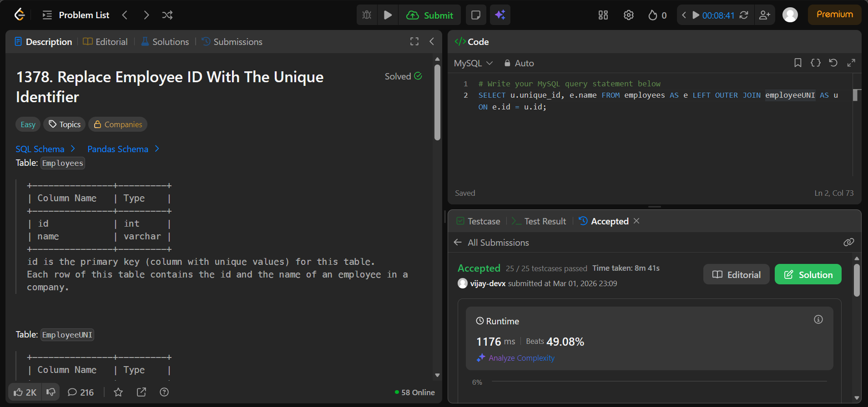

- Product Sales Analysis I https://leetcode.com/problems/product-sales-analysis-i

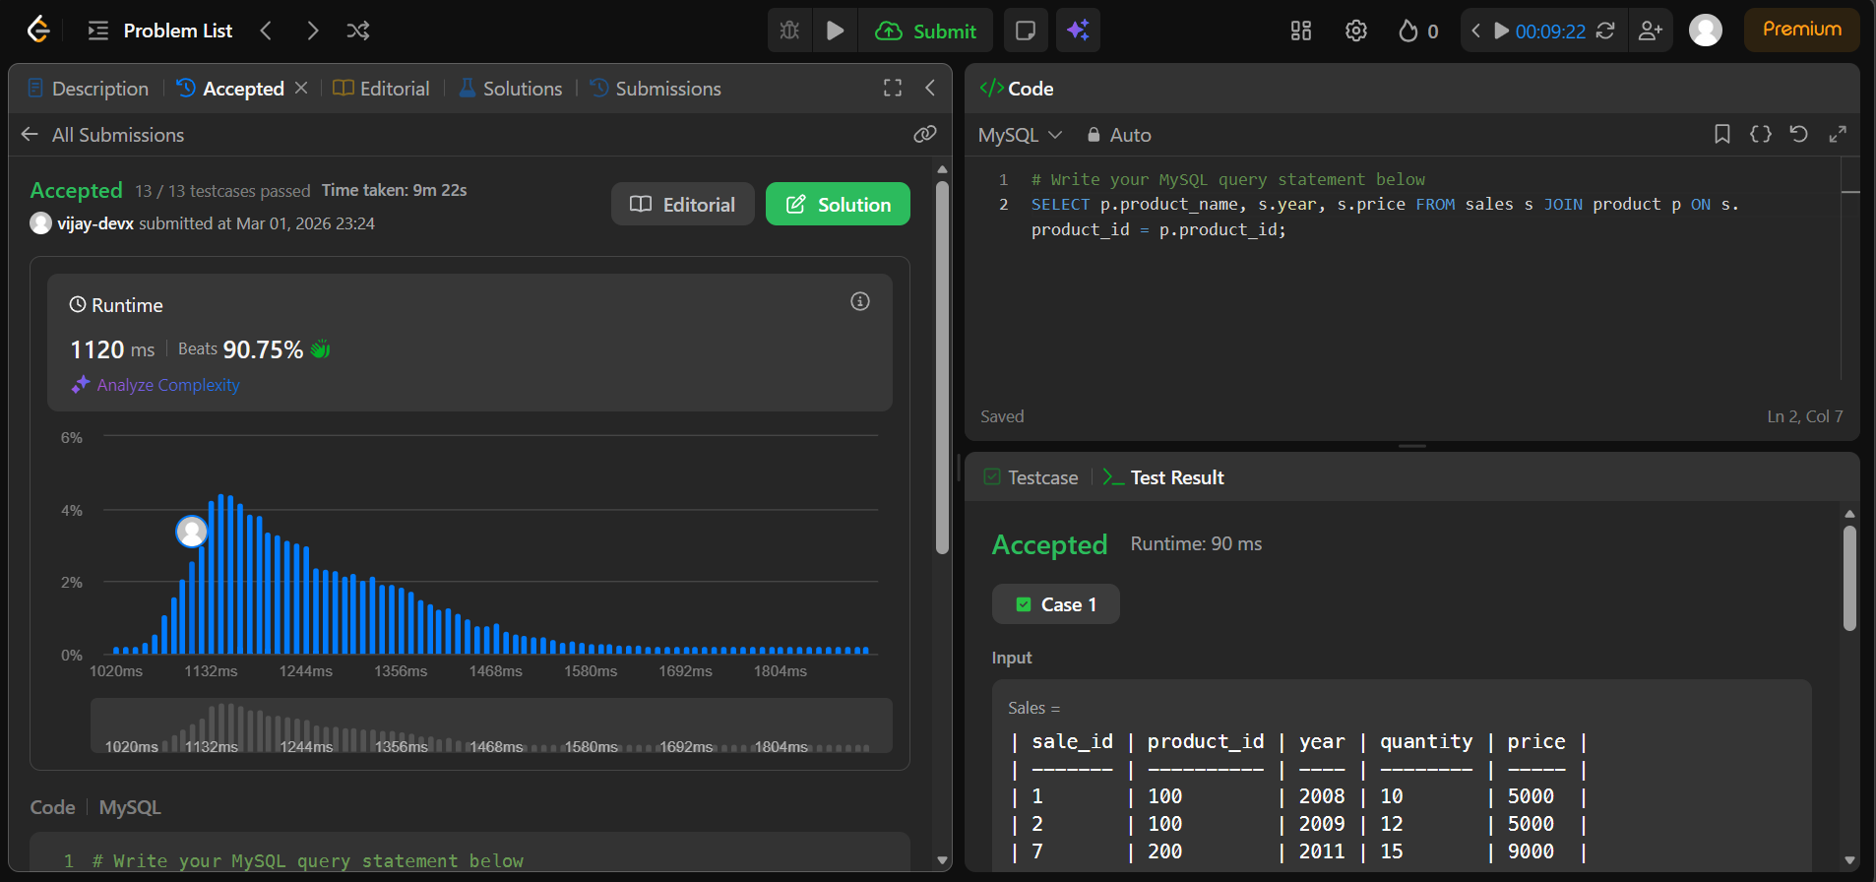

- Employee Bonus https://leetcode.com/problems/employee-bonus

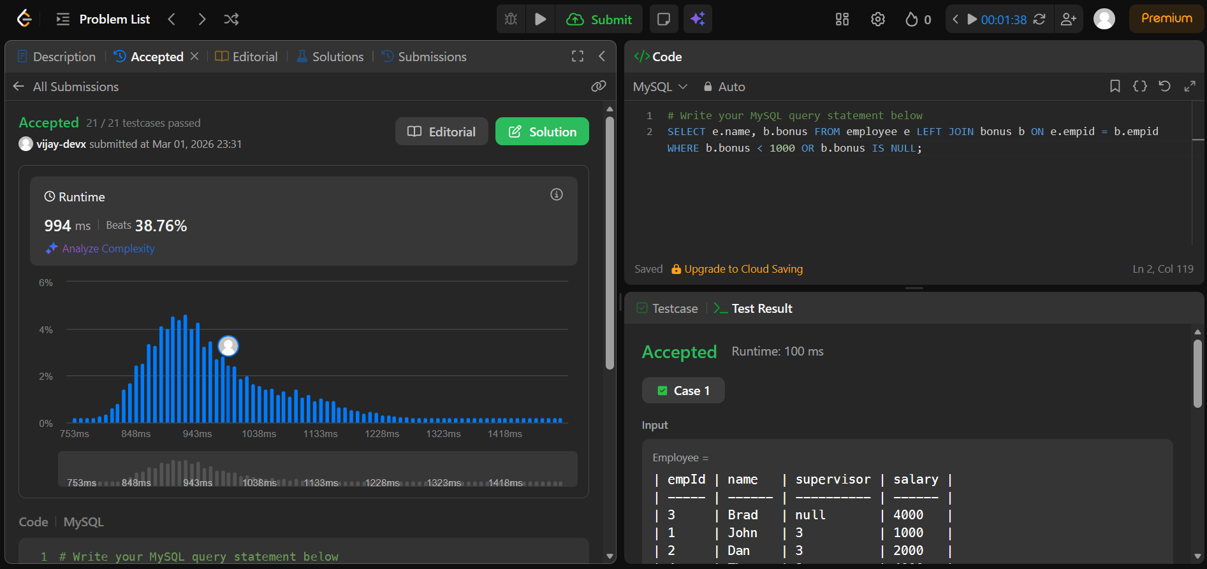

- Students and Examinations https://leetcode.com/problems/students-and-examinations

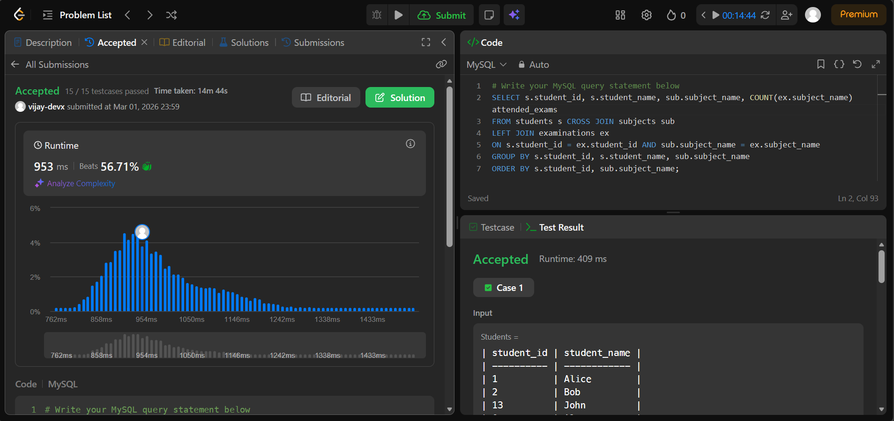

- Managers With At Least 5 Direct Reports https://leetcode.com/problems/managers-with-at-least-5-direct-reports

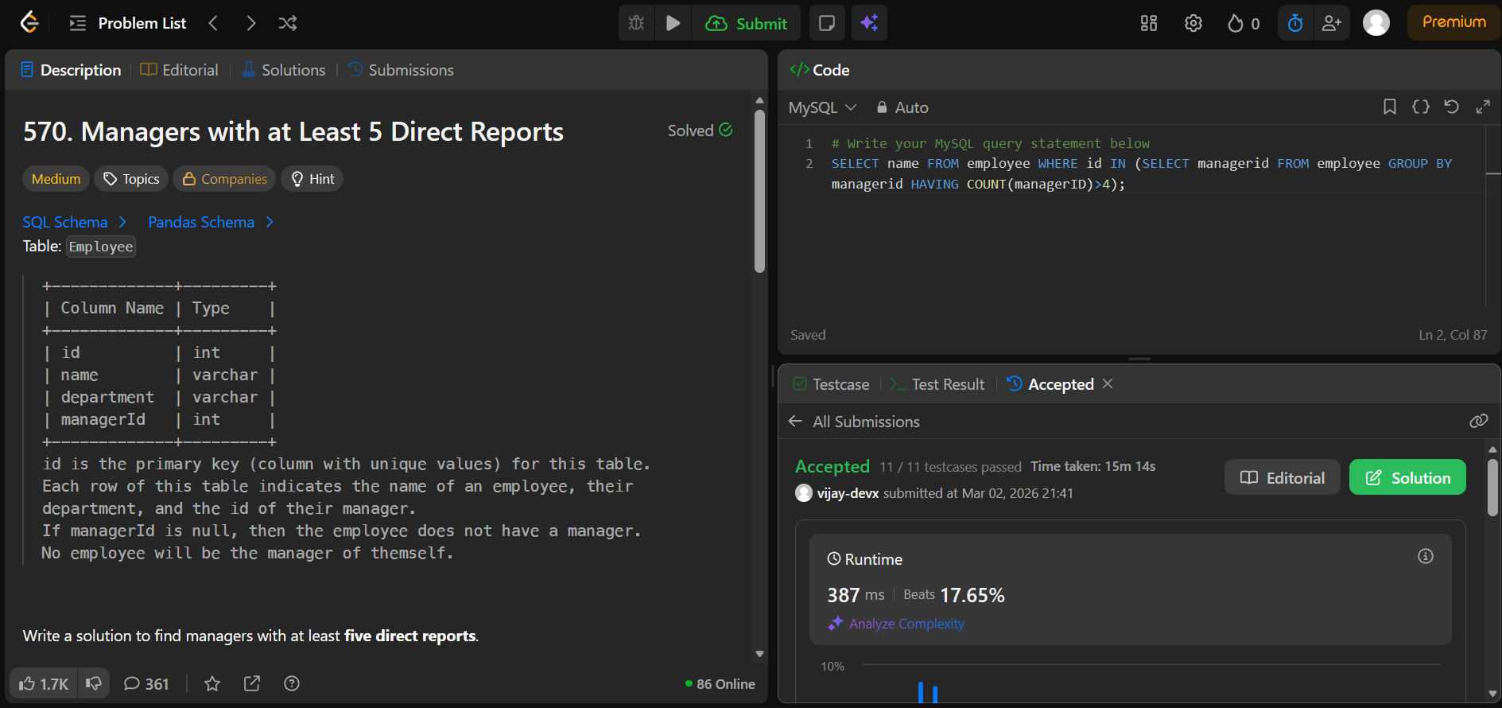

- Asian Population https://www.hackerrank.com/challenges/asian-population

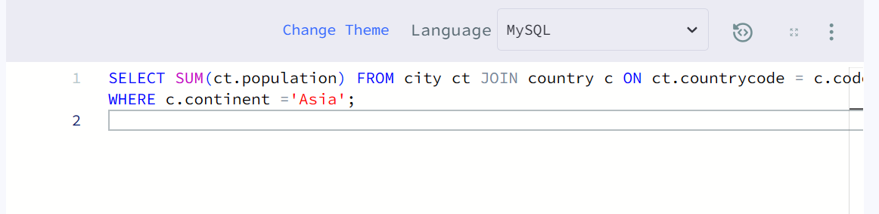
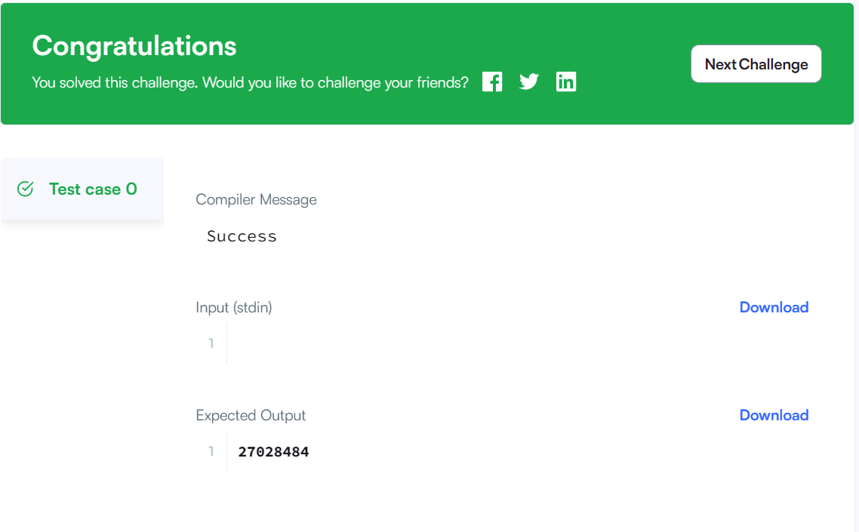

- Average Population of Each Continent https://www.hackerrank.com/challenges/average-population-of-each-continent

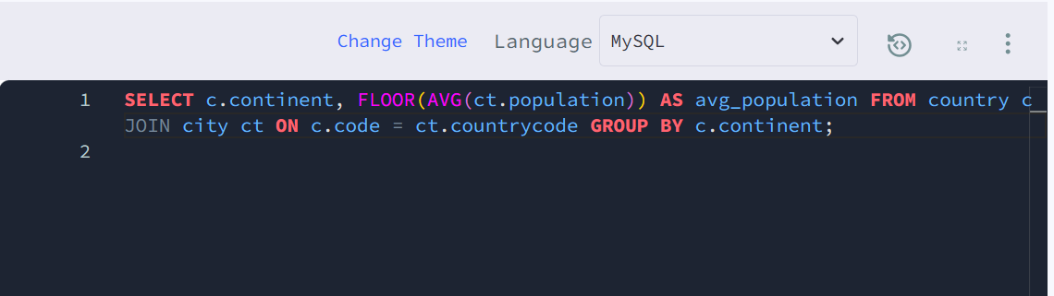
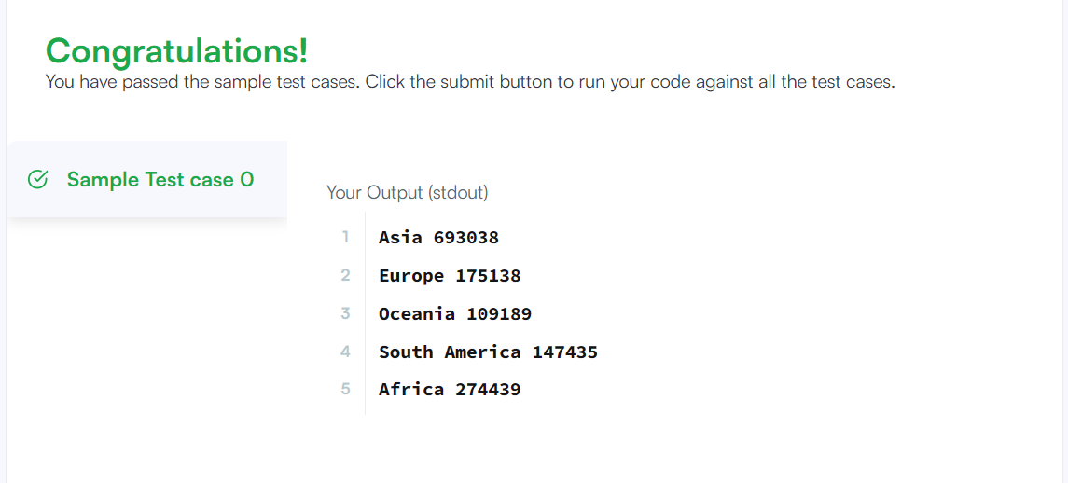

- Last Person to Fit in the Bus https://leetcode.com/problems/last-person-to-fit-in-the-bus

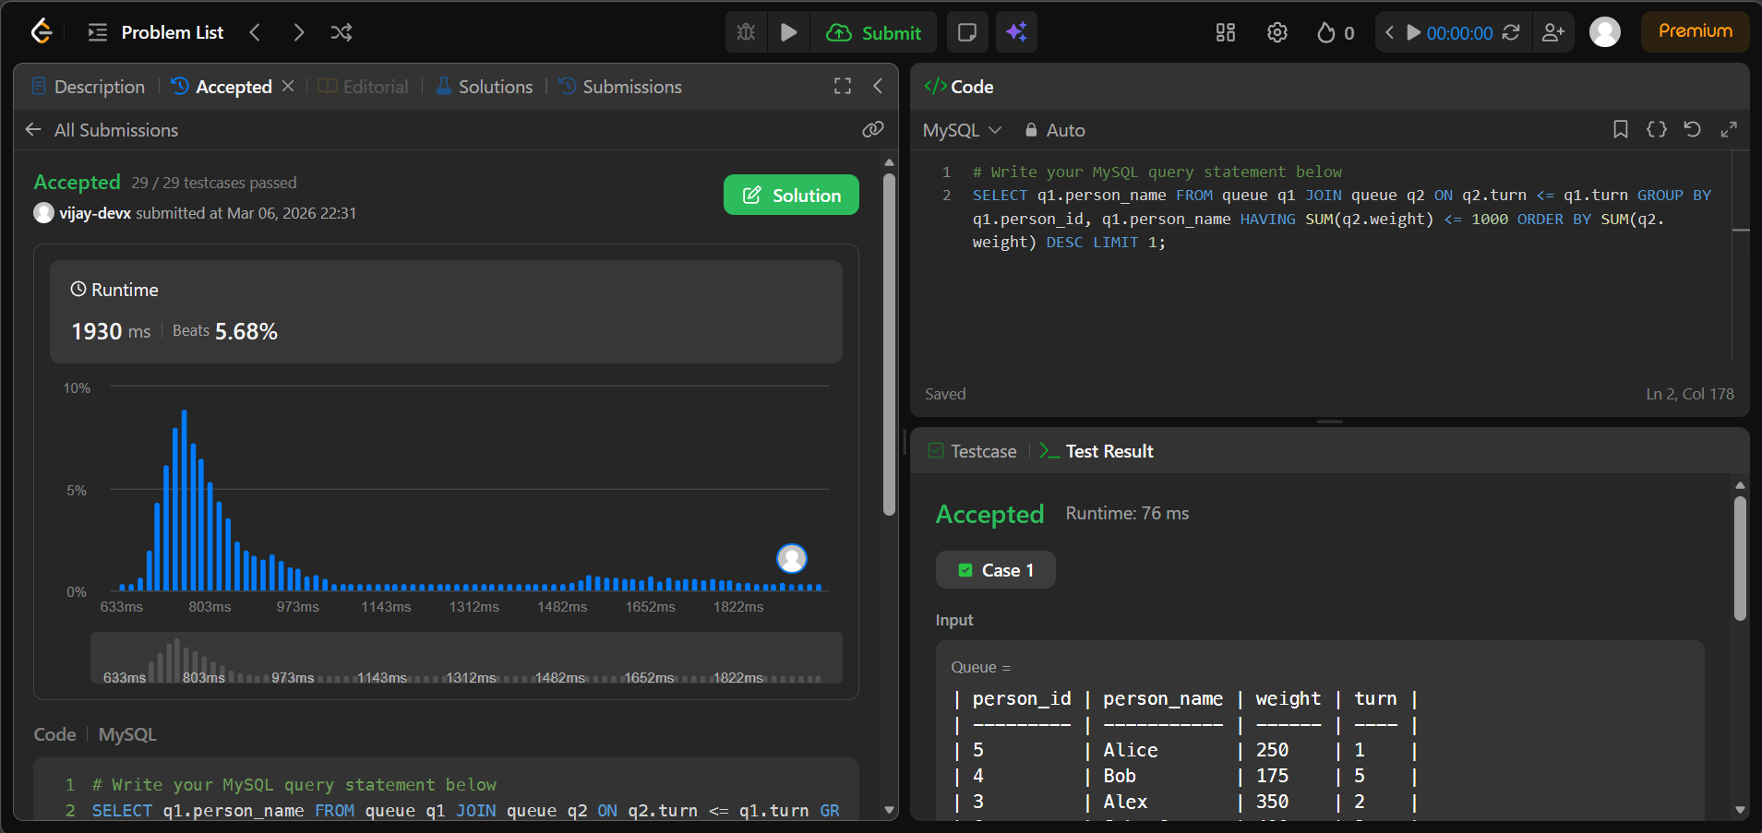
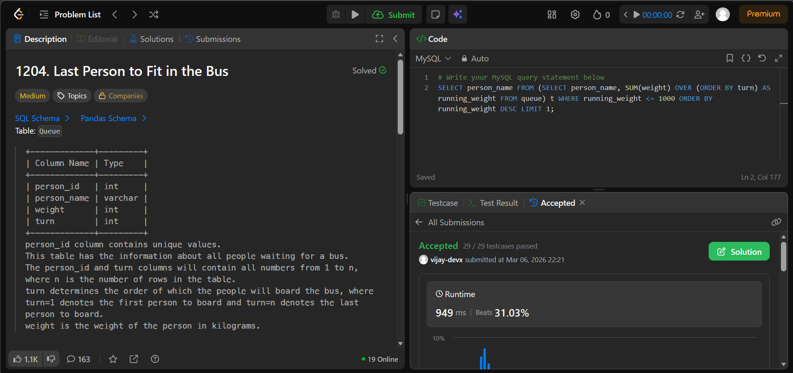

- Product Price at a Given Date https://leetcode.com/problems/product-price-at-a-given-date

